My numberland
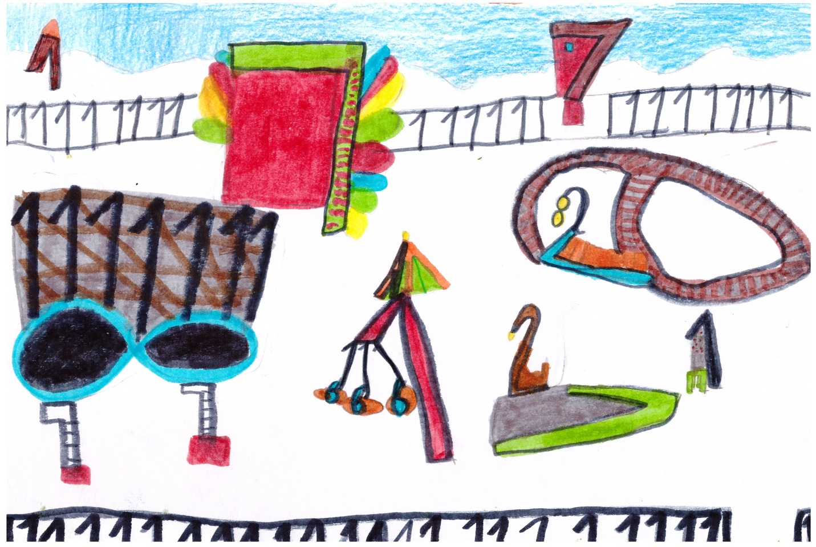
I‘m Austeja. I drew an amusement park. I love to be in it.

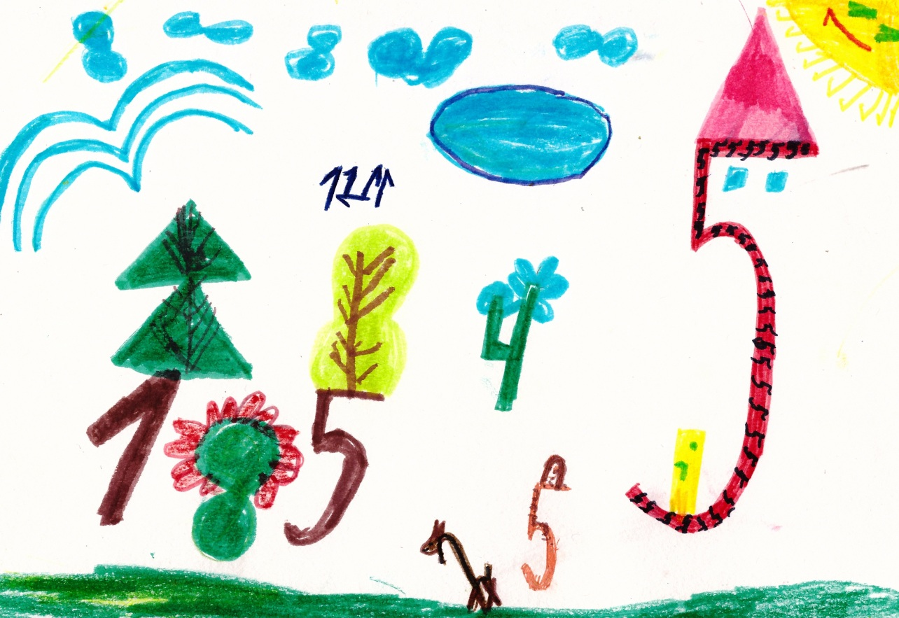

I‘m Kamile. I drew my house, yard. I love to be at home.
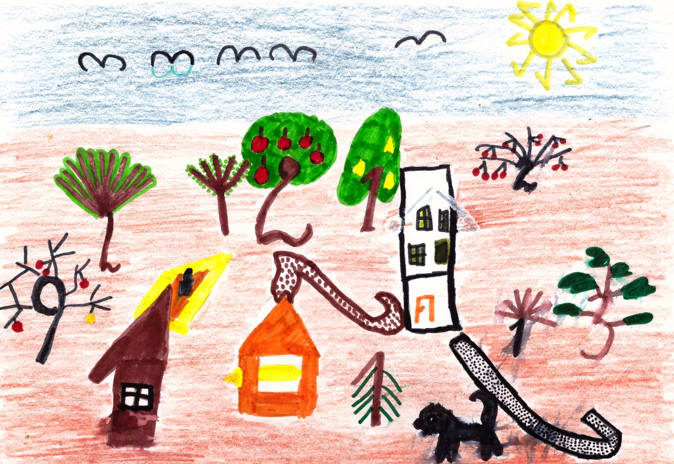
I‘m Liepa. I drew my house, the yard, the garden. I have two dogs. I love to play with my dogs and I like to be in the garden.

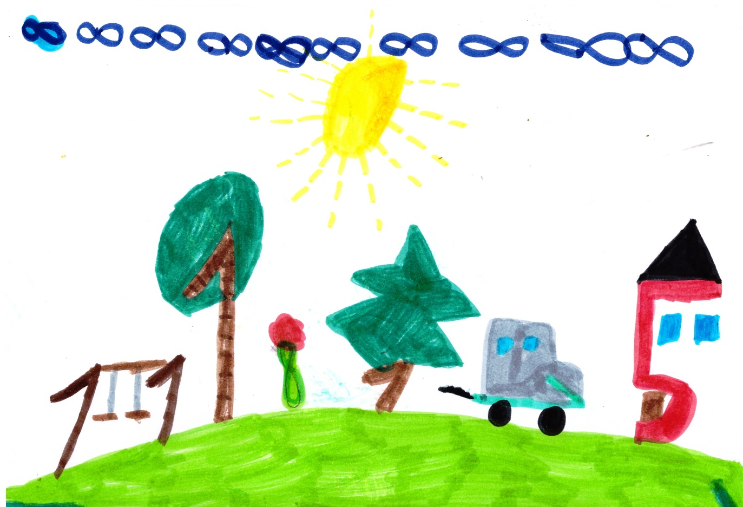
I‘m Edgaras. I drew my house, my garden. I like to swing with a swing and to travel with my parents.

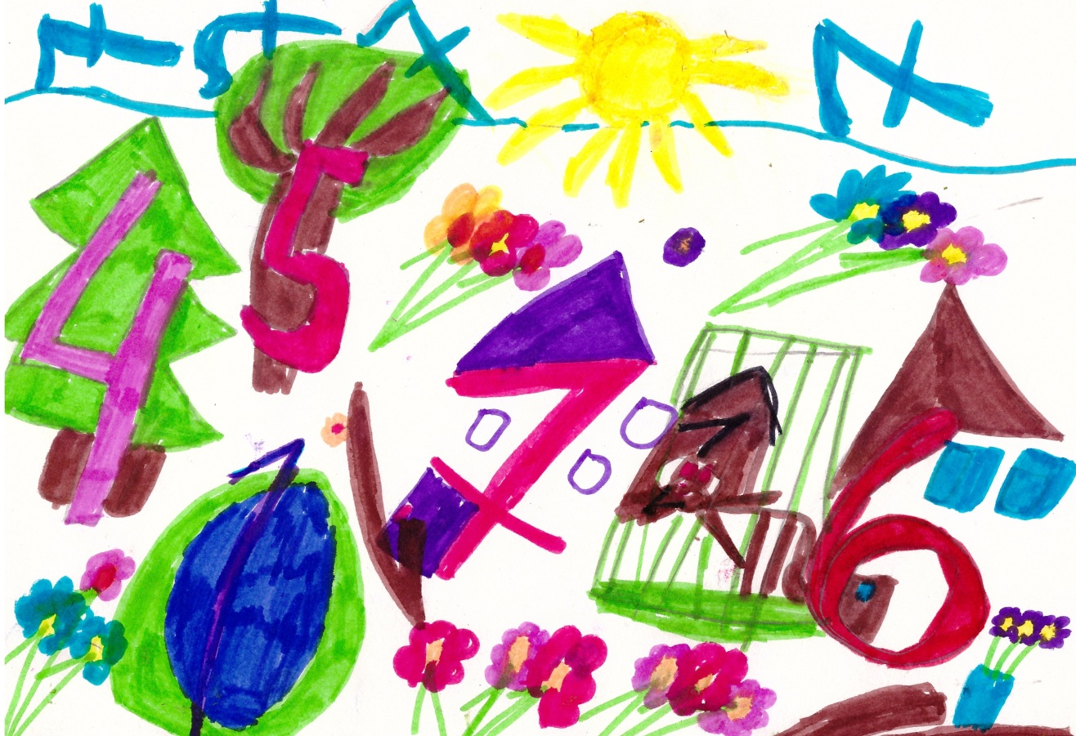
I‘m Rugile. I drew my house, my garden. I like to swim in my pool and to pluck flowers in my garden.

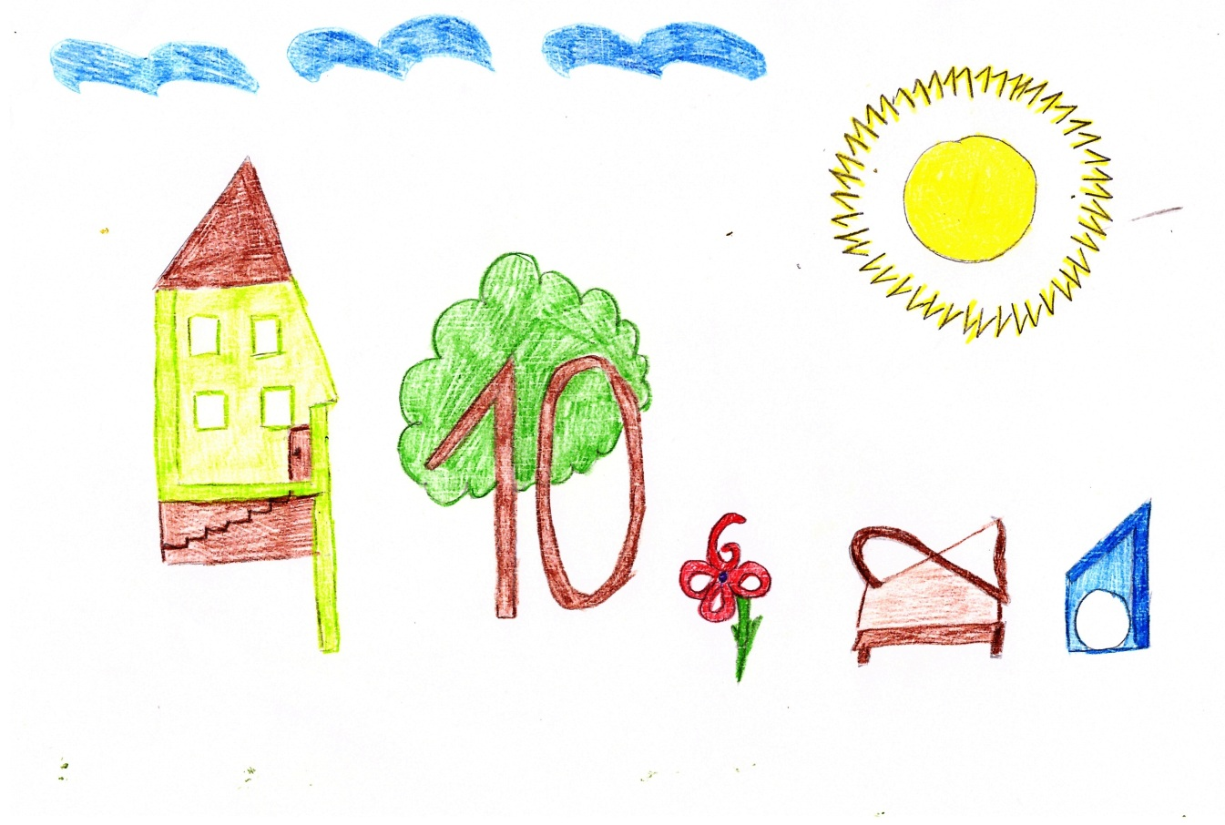
I‘m Vilte. I drew my house, my yard. I like to be in yard and to play with my friends.

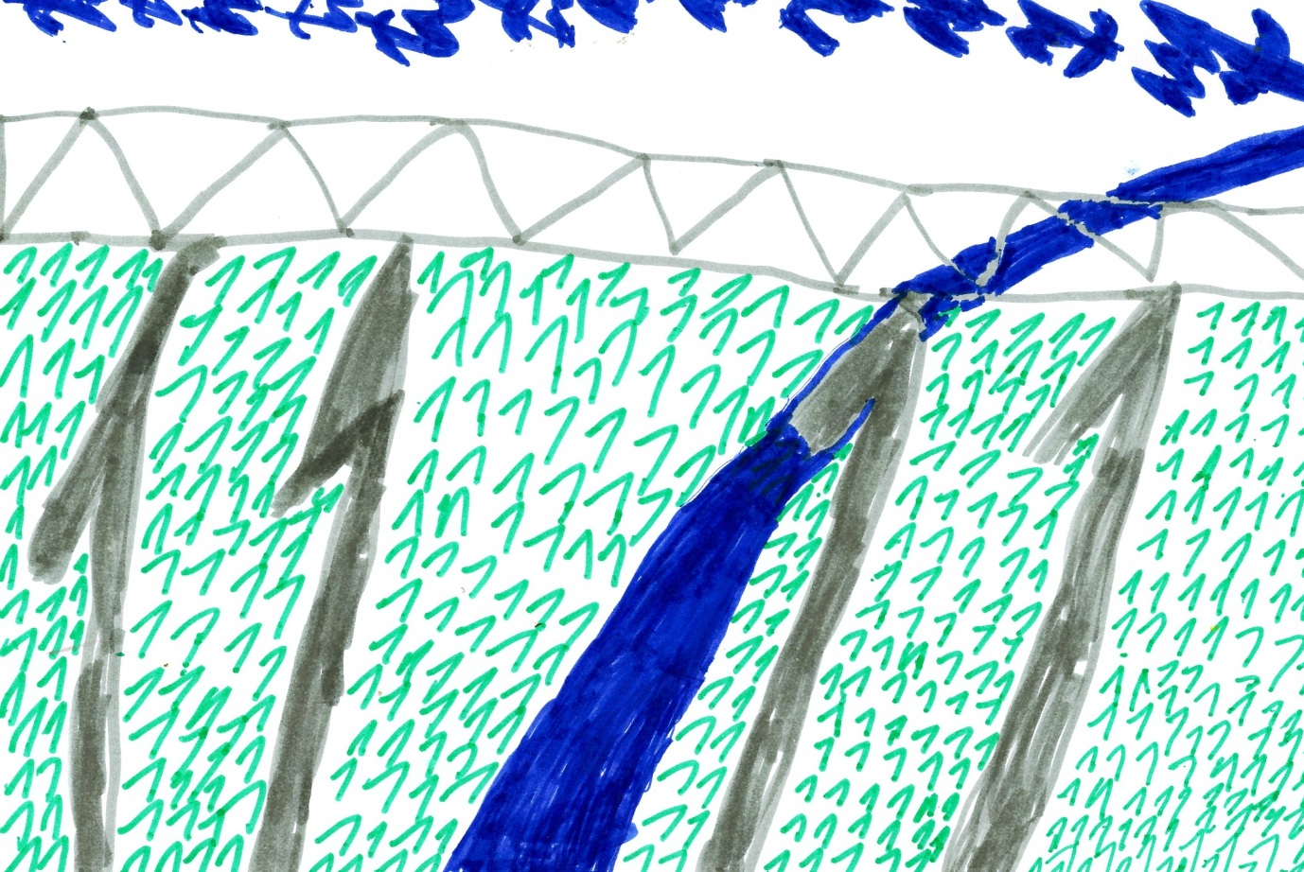
I'm Gvidas. I drew bridge, which is near Raseiniai. It's bigest bridge in the Lithuania.

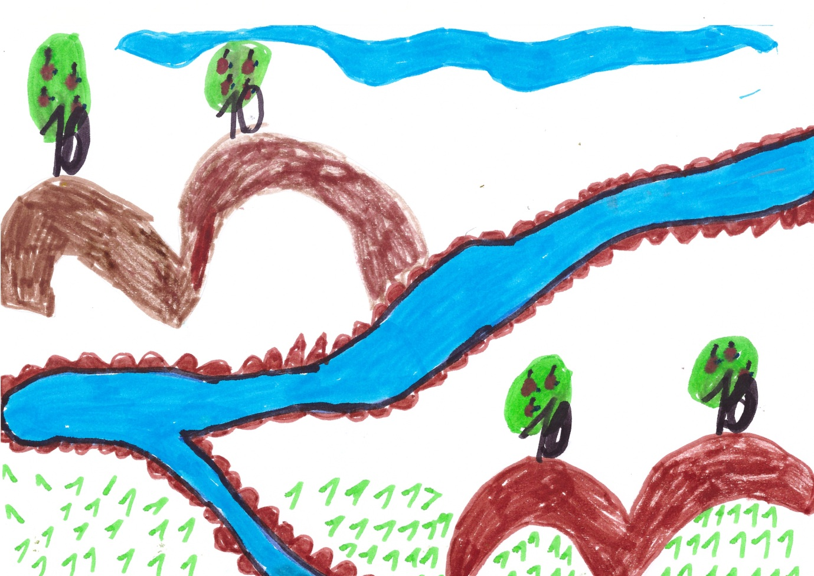
I'm Faustas. I drew river Dubysa, which is near Raseiniai. I love to swim in this river.

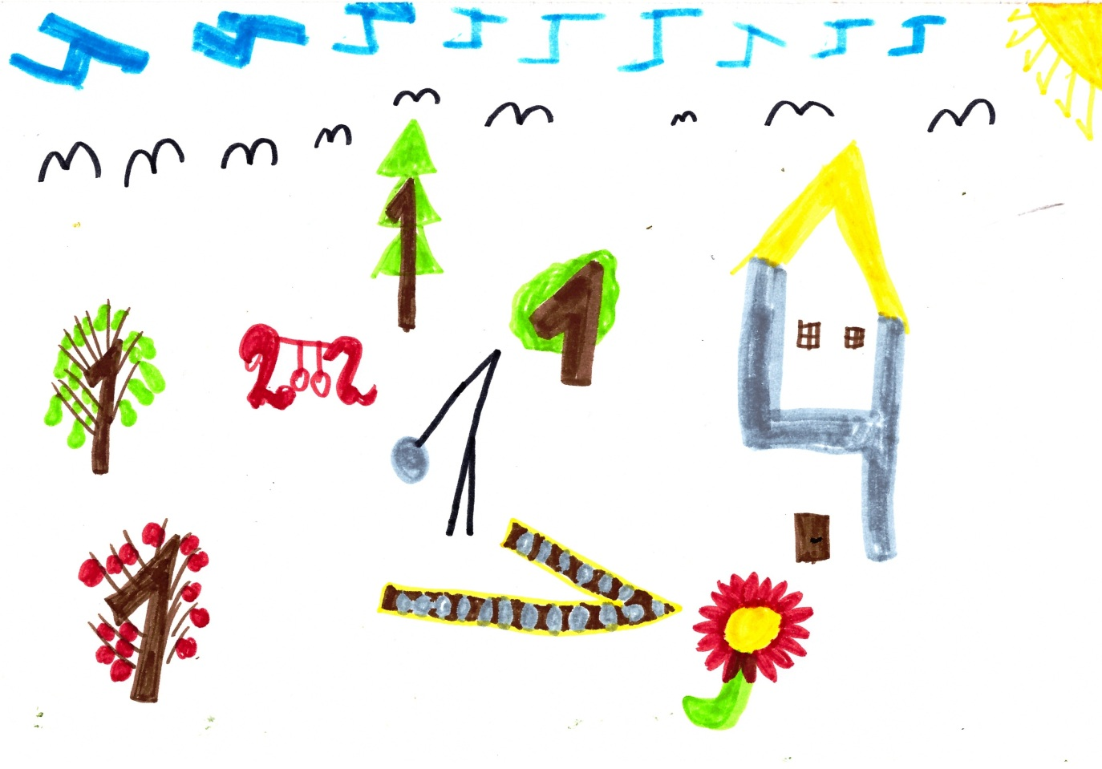
I'm Deimante. I drew my house, my yard. I like to play there.

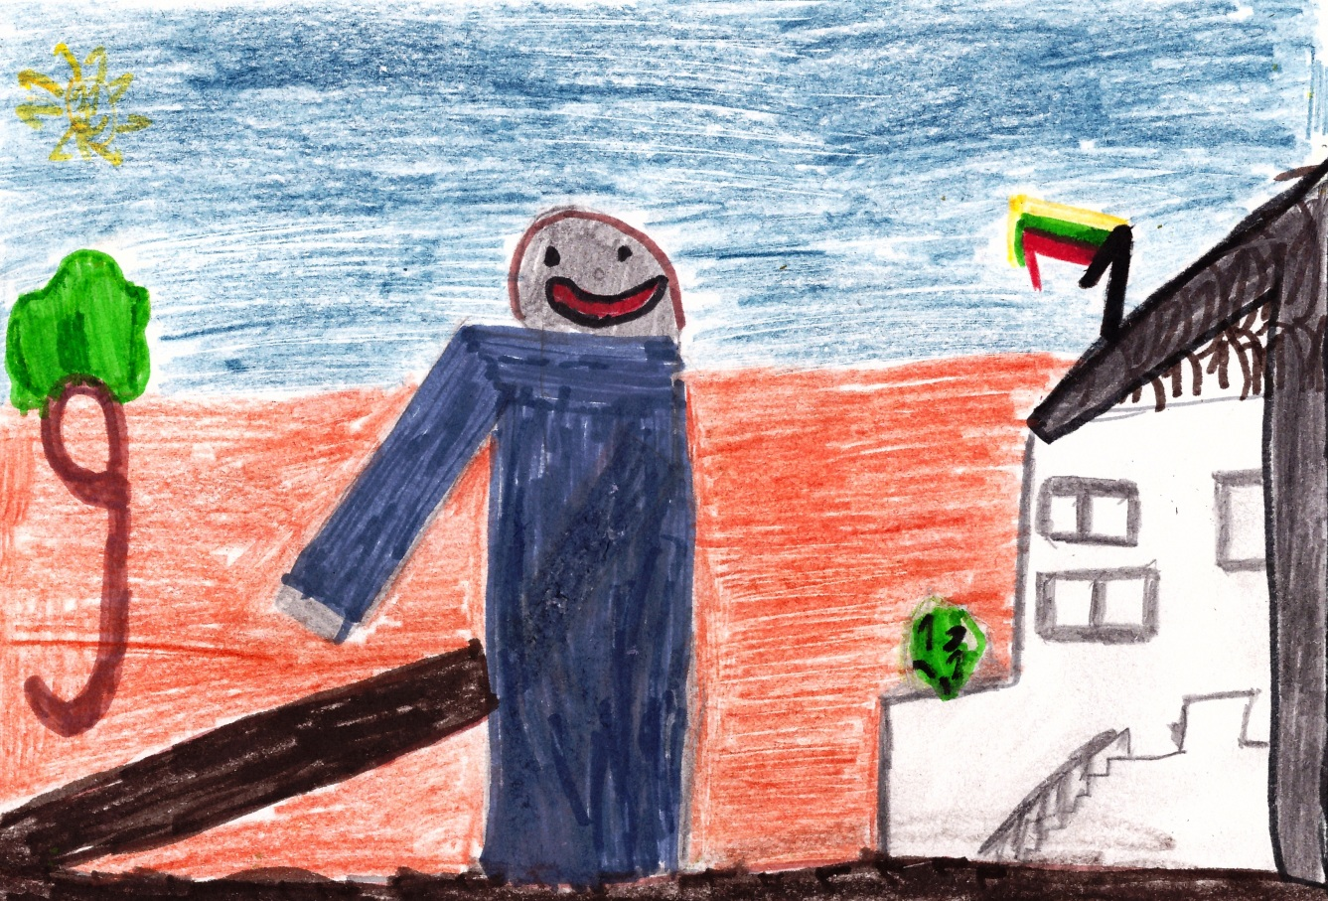
I'm Gediminas. I drew a square, where is the Municipal. There is a monument "Zemaitis" in this square. Events takes place here. I love to participate in them.
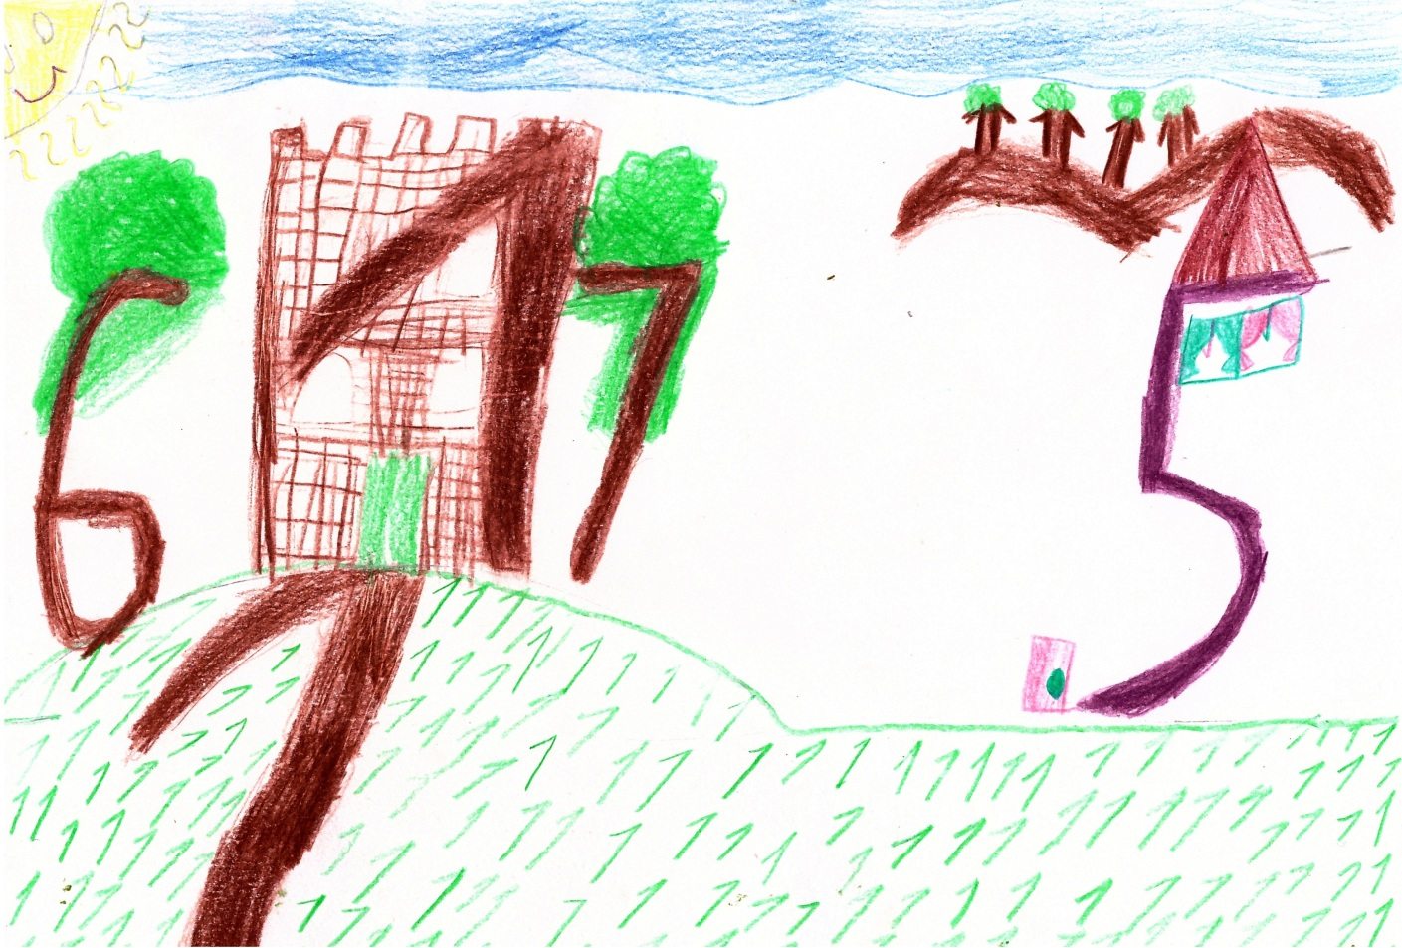
I'm Austeja. I drew the castle of Gediminas. In this castle lived this duke. I like the castle.

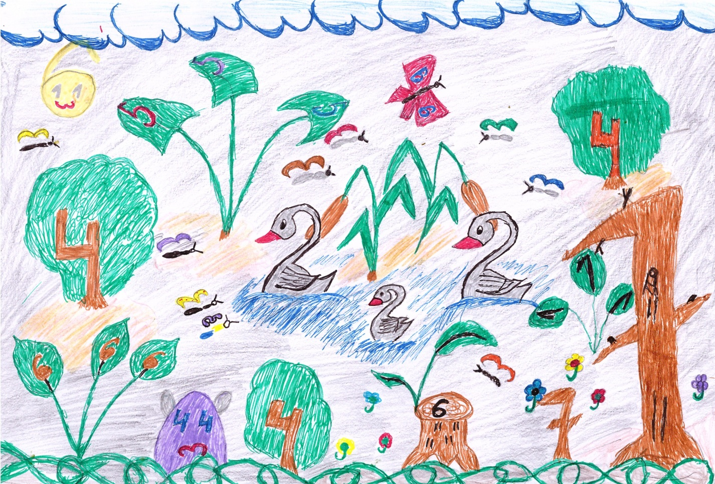
I'm Dovydas. I drew the pond. I like to watch, when swans are flying. I like to swim in the pond during the summer.

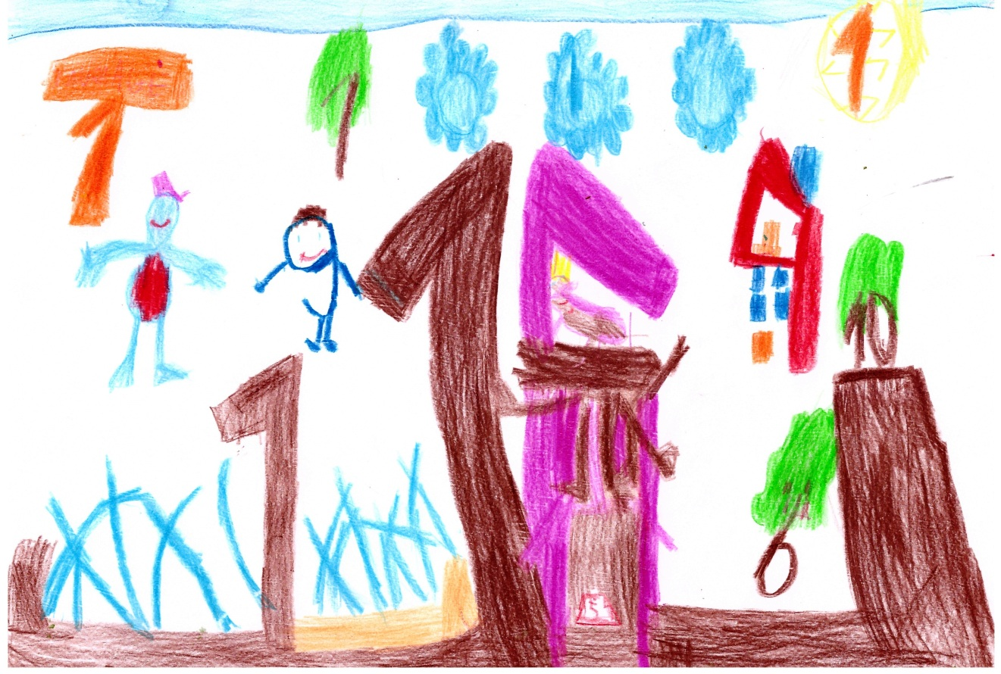
I'm Aretas. I drew a square, a fountain. I like to watch in it.

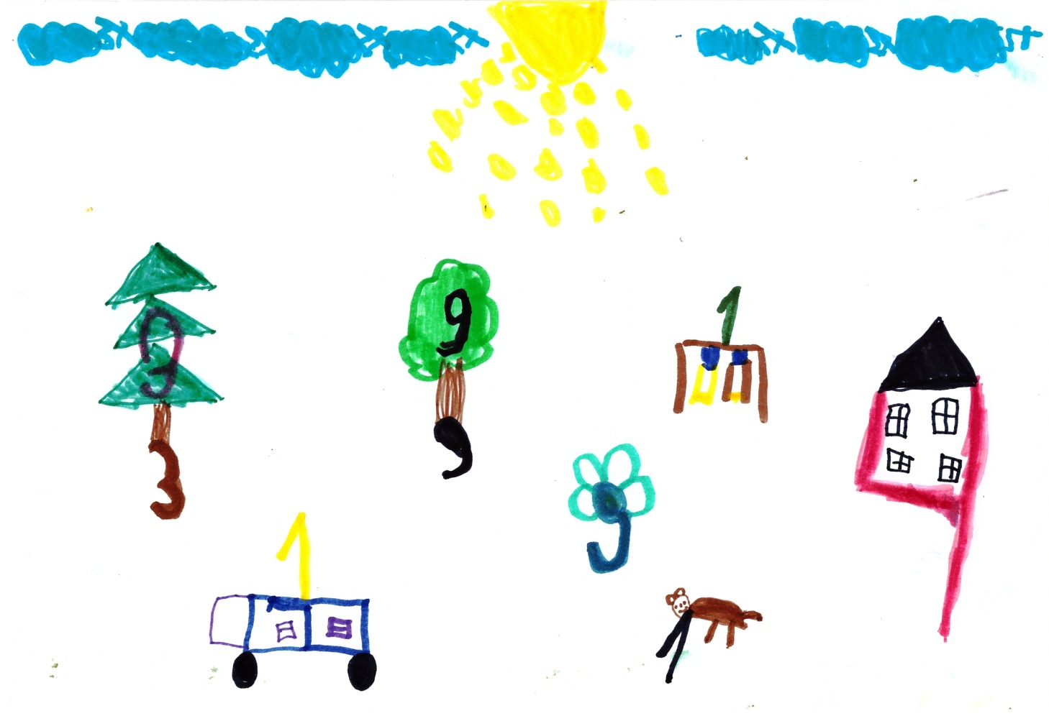
I‘m Emilija. I drew my house. I love to live here.

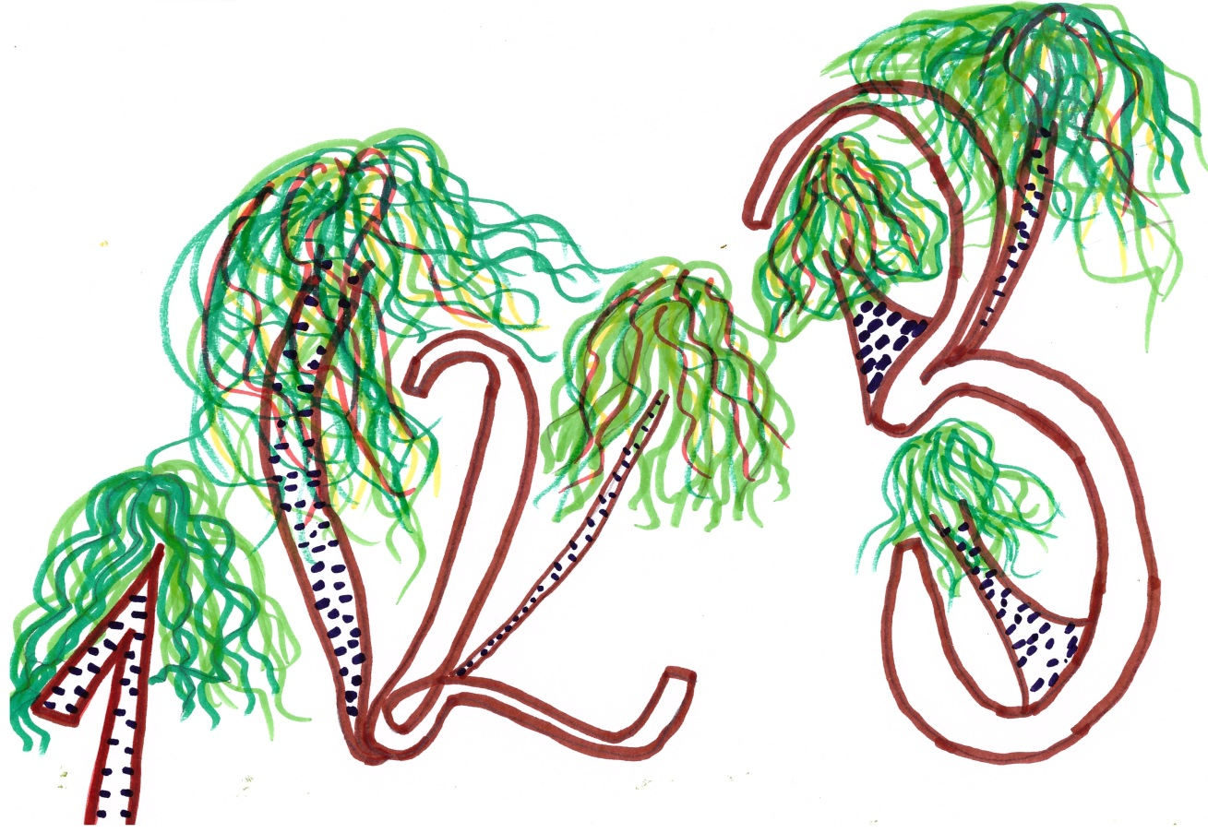
I‘m Martyna. I drew the park. I like to be there.

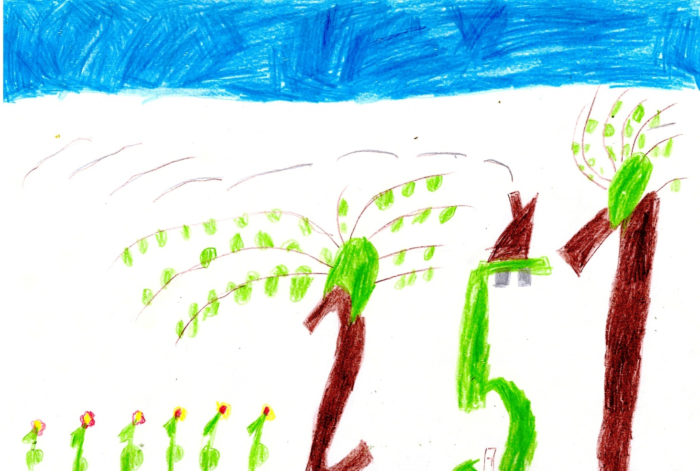
I‘m Adrijus. I drew my house, my yard. I love it.

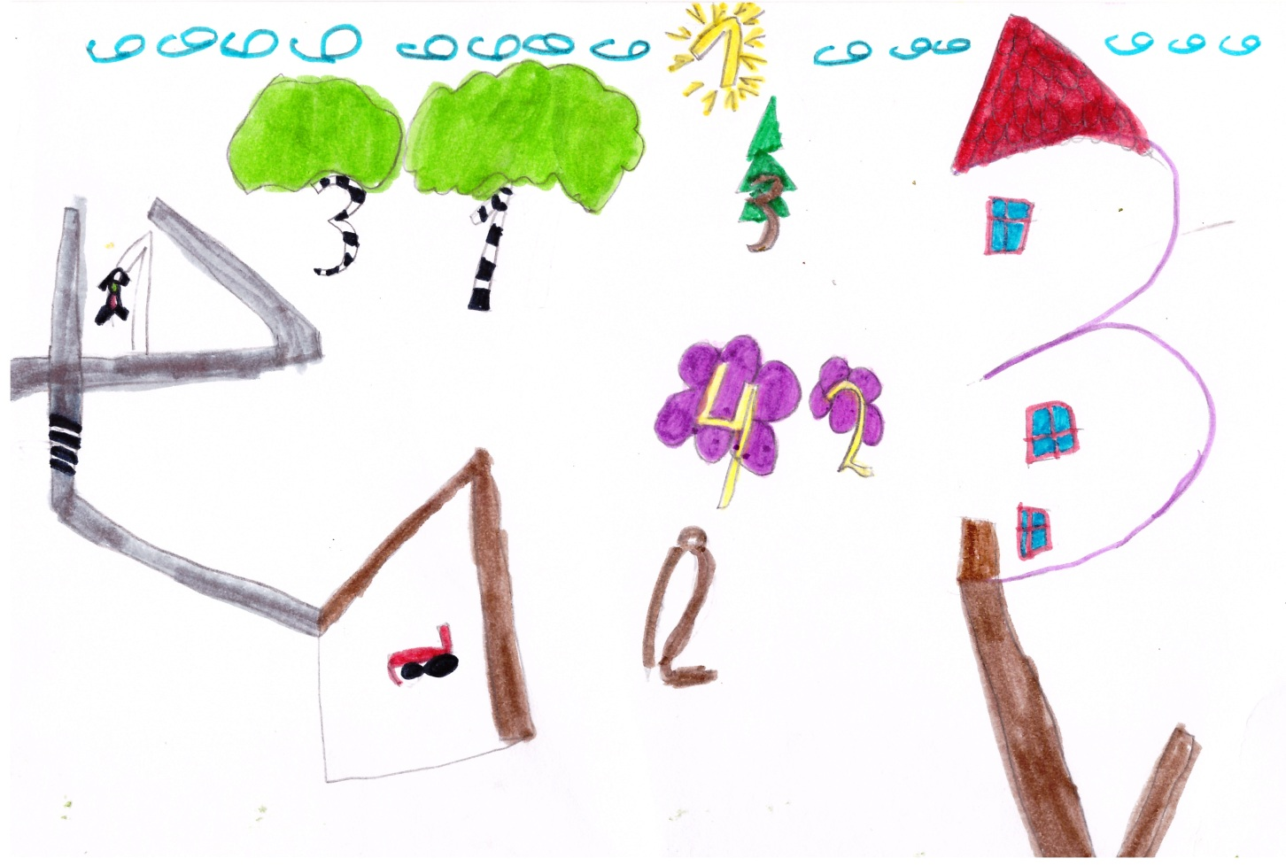
I drew my house, a playground. I love to be in nature near my house.
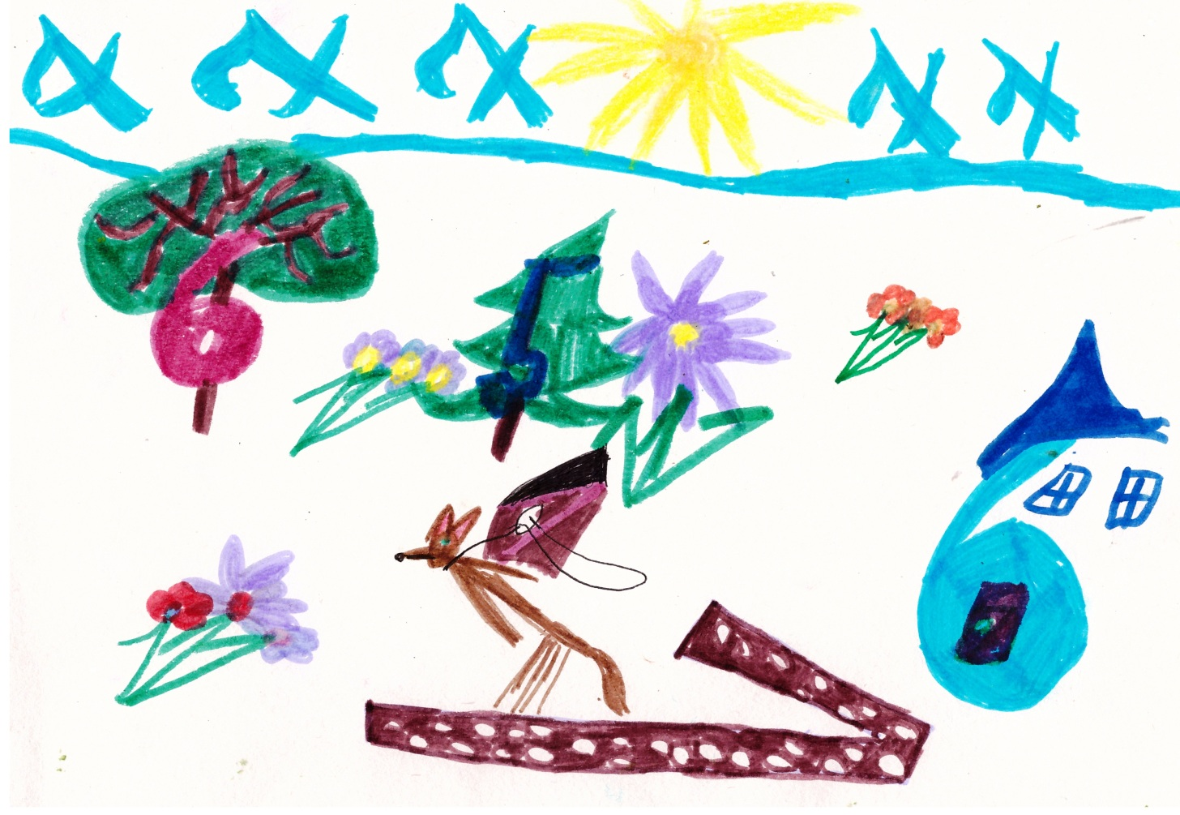
I drew my garden. There is dog in the garden. It keeps us.

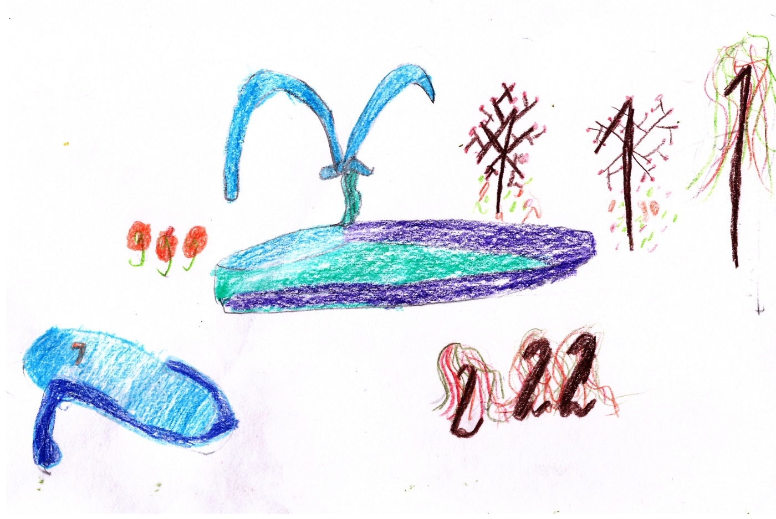
I drew a park. There are a fountain, two pools. I love it.
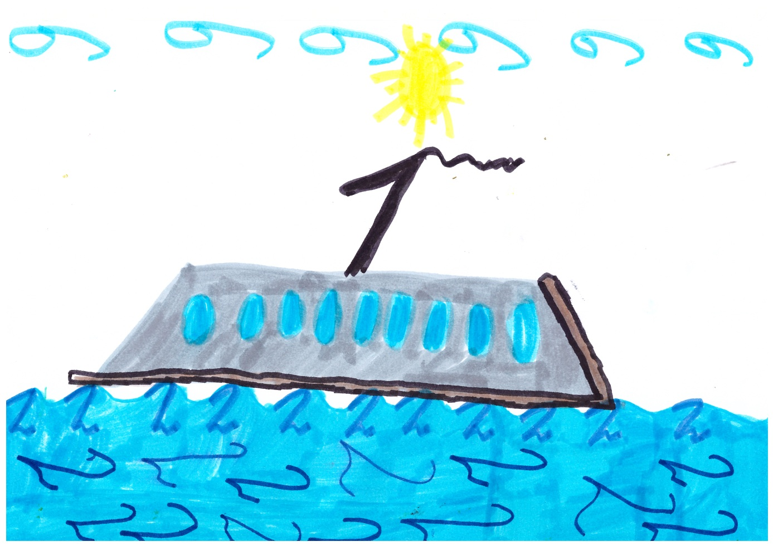
I drew the Baltic sea. There is ship in the sea. I love to swim there.

